IN THE SUPREME COURT OF INDIA
I.A. NO. ________ OF 2022
IN
WRIT PETITION (Civil) NO. 580/2021
IN THE MATTER OF:
Evara Foundation …Petitioner(s) Versus
Union of India and Ors. …Respondent(s)
AND IN THE MATTER
Vidhi Centre for Legal Policy … Applicant/Intervenor
(PAPER BOOK)
(FOR INDEX KINDLY SEE INSIDE)
________________________________________________________________ ADVOCATE FOR THE APPLICANT: ZOHEB HOSSAIN ________________________________________________________________
INDEX
S. No. | Particulars | Page No.
1. | Application for intervention along with Affidavit | 1-18
2. | Annexure A-1:  A True Copy of the memorandum of understanding between Vidhi and NCPEDP. | 19-25
3. | Annexure A-2:  A True copy of this Hon’ble Court’s order dated 31.05.2021 in Suo Motu Writ Petition (Civil) No. 3 of 2021 | 26-55
4. | Annexure A-3:  A True Copy of the order dated 19.04.2021 passed by the Hon’ble Madras High Court in W.P.No.2951 of 2021 titled Meenakshi Balasubramanian v. Union of India and Ors | 56-58
5. | Vakalatnama. | 59
6. | Authority Letter. | 60-62
7. | Proof of service. | 63

1
IN THE SUPREME COURT OF INDIA
I.A. NO. OF 2022
IN
WRIT PETITION (C) NO. 580/2021
IN THE MATTER OF:
Evara Foundation …Petitioner(s) Versus
Union of India and Ors. …Respondent(s) AND IN THE MATTER:
Vidhi Centre for Legal Policy … Applicant/Intervenor
APPLICATION FOR INTERVENTION IN THE AFORESAID WRIT PETITION
To
The Hon’ble Chief Justice of India and his companion Justices of the Supreme Court of India, New Delhi;
The humble application of the
Applicant above-named;
MOST RESPECTFULLY SHEWETH:
1. That the Applicant/Intervenor herein, Vidhi Centre for Legal Policy (“Vidhi”) is a not-for-profit company set up under Section 25 of the Companies Act, 1956 in 2013. Vidhi does legal research to make better laws and improve governance for the public good. Under a series titled ‘Lest We Forget’, Vidhi is running a series of projects to derive key learnings as to what should be the most appropriate response to different
2
facets of a public health emergency like the COVID-19 pandemic. One such project is on access to healthcare for persons with disabilities [“PwDs”] during the COVID-19 pandemic. A core issue area covered within this theme is access to COVID vaccines.
2. That the present Intervention Application is being filed in support of Writ Petition (C) No. 580/2021.This writ petition seeks augmentation of the support facilities to ensure seamless access to vaccinations forPwDs. Vide order dated 25.01.2022, this Hon’ble Court directed the Department of Empowerment for Persons with Disabilities [“DEPwd”] to invite suggestions from all stakeholders and domain experts in the area of disability for further upgradation of the existing framework of vaccination for PwDs to make it more effective. The DEPwD was directed to then place comprehensive proposals before the Ministry of Health and Family Welfare. The Secretary in the Ministry of Health and Family Welfare was mandated to take a considered view of such proposals and take a decision on whether any modification or changes are required to make the existing framework of vaccination for PwDs more effective.
3. Vidhi has entered into a collaboration with the National Centre for Promotion of Employment of Disabled People (“NCPEDP”) to assess access to healthcare services for PwDs during the pandemic.The project analyses the following issues:
a. Ability of persons with disabilities to access medical care, related and unrelated to COVID-19 (e.g., medicines, in-patient care, emergency care, rehabilitation services, etc.)
3
b. Impact of vaccine policies on PwDs, with reference to: [a] door to-door vaccination; [b] accessibility of the CoWin platform; [c] critical analysis ofthe Guidelines on Near to Home Vaccination released by the Union Ministry of Health and Family Welfare; and [d] creation of a separate support system for the benefit of PwDs.
c. Accessibility of healthcare-related information for PwDs during the COVID-19 pandemic.
A True Copy of the memorandum of understanding between Vidhi and NCPEDP is attached as Annexure A-1 at pages 19 to 25.
4. The suggestions below are a product of:
a. A survey conducted by Vidhi and NCPEDP, featuring 279 PwDs; and
B. Vidhi’s independent research on the problems in vaccination faced by PwDs and best practices in other jurisdictions.
A True Copy of the raw data sheet containing the results of the survey conducted by Vidhi and NCPEDP will be produced before this Hon’ble Court, if so directed.
5. The key findings arrived at by Vidhi that form the basis for the recommendations made in this IA are as follows:
∙ While the CoWIN platform has become more accessible for the visually challenged pursuant to this Court’s intervention, some accessibility barriers on the platform remain.
∙ There is a need to enable PwDs to book vaccine appointments on the phone.
4
∙ There is a need to provide appropriate know-how to the staff manning existing COVID helplines, to equip them to assist PwDs.
∙ A series of targeted interventions must be undertaken to ensure that the staff manning vaccine centres is duly sensitized to the needs of PwDs and that such vaccine centres contain disabled friendly physical infrastructure.
∙ A question should be added in vaccine registration forms, to bring into play the support system generated for PwDs in the vaccination process and to collect data on the vaccination of PwDs.
∙ PwDs must be given priority in vaccine administration at vaccine centres, by taking the recommended measures in this regard.
∙ Steps must be taken to operationalize door-to-door vaccination and near-to-home vaccination for PwDs.
∙ A grievance redressal mechanism should be created to enable PwDs to complain about accessibility barriers faced in getting vaccinated.
Accessibility of the CoWIN Platform:
6. Vidhi and NCPEDP’s survey shows that only 36.9% of 268 respondents could register themselves on CoWIN, and of those, only 28.9% could do so independently. In its order dated 31.05.2021 in Suo Motu Writ Petition (Civil) No. 3 of 2021 in Re: Distribution Of Essential Supplies And Services During Pandemic, this Hon’ble Court had flagged up a series of issues with the accessibility of the CoWIN platform for the visually impaired. Relevant excerpt of this Court’s order is below:
5
“42 It has been brought to our notice that the CoWIN platform is not accessible to persons with visual disabilities. The website suffers from certain accessibility barriers which should be addressed. These include:
(i) Audio or text captcha is not available;
(ii) The seven filters, which inter alia, include age group, name of vaccine and whether the vaccine is paid or free, are not designed accessibly. This issue can be addressed by creation of a drop-down list;
(iii) While visually challenged persons can determine the number of available vaccine slots, one cannot find out the day those slots correspond to. This can be resolved by ensuring that table headers correspond to associated cells;
(iv) Keyboard support for navigating the website is absent;
(v) Adequate time should be given to disabled users to schedule their appointment without the possibility of being automatically logged off; and
(vi) Accessibility protocols, such as use of appropriate colour contrasts, should be adhered to.”
A True copy of this Hon’ble Court’s order dated 31.05.2021 in Suo Motu Writ Petition (Civil) No. 3 of 2021is annexed as
AnnexureA-2 at page 26 to 55.
6
7. It is heartening to note that, pursuant to this Hon’ble Court’s order, the CoWIN platform has become much more accessible for PwDs. There are, however, still some outstanding accessibility issues as follows:
a. While a visually challenged user can independently navigate the filters and get to the desired centres, she cannot book a vaccine slot. Specifically, pressing enter on the number of available slots does not select the slot. This number has to be clicked in order to book a slot. A keyboard trigger event must be added to the element to make it accessible with a keyboard.
b. Drop down menus for the following options are inaccessible with a keyboard: (a) Vaccination Services; (b) Platforms; (c) Resources; and (d) Support. Illustratively, under vaccination services’, available options such as ‘download certificate’ and ‘manage appointments’ cannot be selected with a keyboard. A keyboard trigger event must be added for each of these options.
c. The CoWIN platform should have a separate webpage on vaccinating the disabled that outlines the dos and don’ts to be followed in this regard.
D. In addition to implementing the above changes, a thorough accessibility audit should be conducted of the CoWIN platform and suitable remedial measures should be taken in a time-bound manner.
Enabling PwDs to book vaccine appointments on the phone:
8. Existing COVID-19 helplines [104 and 1075] need to be reconfigured to meet the needs of PwDs. Specifically, an option should be added to enable PwDs to book their appointments for vaccination on the phone. However, the upgradation of the helpline should be pursued independently from the accessibility of the CoWIN platform. Just because
7
PwDs will be able to book appointments using the helpline should not furnish a valid justification for a failure to make the CoWIN platform fully disabled friendly.
9. Further, the following measures should be taken to make COVID-19 helplines work for PwDs:
a. On existing COVID helplines [1075, 104 and any other such numbers], the staff manning such helplines must be provided sensitization training to equip them to address the needs of citizens with disabilities. The DEPwD should conduct such a sensitization training in which PwDs should themselves lead the training.
b. The DEPwD should issue a list of FAQs on the kinds of questions that citizens with disabilities might ask, for the benefit of those manning such helplines, to enable staff to be trained to assist them appropriately. Some questions that the list can include are:
● How can I obtain reasonable accommodation at the vaccine centre? ● How can I ask for human help at the vaccine centre?
● How can I access the facility of being vaccinated at home, as a PwD who cannot travel to a vaccine centre?
● How can I obtain information about the vaccination process in an accessible format?
C. DEPwD must audit the helpline, on at least a monthly basis, to ensure that those manning it have the know-how and sensitivity to assist PwDs appropriately.
Walk-in registration:
8
10. While walk-in registration may generally improve ease of access, it should not be viewed as the appropriate solution for accessibility barriers for PwDs, given that some such individuals are high-risk, and any overcrowding at walk-in vaccinations centres may pose an additional risk to them. Keeping this in mind, the following measures should be taken:
a. Provision of disability-specific sensitivity training to the staff responsible for granting registration for vaccinations to PwDs, as well as availability of technically competent persons, such as sign language interpreters.
b. Provision of safe and accessible waiting rooms for PwDs to minimise exposure to COVID-19.
Prompt in vaccination form to indicate disability:
11. The registration form should have the option to indicate whether one has any form of disability, for which reasonable accommodations may be made. This will lead to informed coordination in vaccination centres, and increase accessibility for PwDs. A sample question is: “Please indicate whether you have any form of disability, and if yes, please specify the kind of disability. This is to ensure that the vaccination centre that you visit will be accessible for you.”
12. Clarifying the purpose of asking this question in the form itself will ensure that PwDs do not get dissuaded from seeking vaccination under any false notions about vaccination as a PwD flowing from the addition of this question. It will ensure that the requisite data is collected, while also avoiding any harmful effects. Asking a question will be a more useful metric to gauge the numbers of pwDs vaccinated than using UDID cards.
9
Accessibility of vaccination centres:
13. Section 25(1)(b) of the Rights of Persons with Disabilities Act, 2016, reads as follows: “25. Healthcare. – (1) The appropriate Government and the local authorities shall take necessary measures for the persons with disabilities to provide, - “Xxx (b) barrier-free access in all parts of Government and private hospitals and other healthcare institutions and centres;”
14. In the survey conducted by Vidhi, only 75.7% of the 235 respondents had received the vaccination, of whom only 56.1% reported it as accessible and 24.9% had to make multiple attempts to get the vaccine. One respondent noted:
“If hospital staff had known sign language knowledge my communication would be easier.”
Another stated:
“Staff trained in sign language needs to be available for those who are deaf and blind.”
15. The following suggestions are offered to make vaccine centres more disabled friendly:
1.Vaccination centres should have appropriately trained resource persons who will be responsible for providing support to PwDs. This includes:
a. Availability of support staff to assist PwDs navigate the vaccination centre with ease (for example, persons to help persons with visual disabilities find the vaccination counter).
10
b. The persons who will be responsible for administering the vaccine and communicating information to beneficiaries should be provided with sensitivity training.
c. Each vaccination centre should appoint technically competent persons, such as sign language interpreters, who can communicate with PwDs, as may be needed (for example, communicating the potential side effects and precautions to be observed in respect of vaccinations). Such persons may be made available on the basis of the number of PwDs expected to visit a vaccination centre on any given day, based on the information solicited from the registration form.
d. A repository of such technically competent persons should be made available to vaccination centres by the DEPwD.
e. All vaccination centres should have a designated point of contact to whom PwDs may reach out to address any questions or concerns. Details of such coordinate persons must be published on the website of the concerned district, onacentre-wise basis.
Accessible infrastructure:
16. To ensure that PwDs can visit vaccination centres, the following infrastructural accessibility requirements must be considered:
a. Parking spots should be designated for persons with disabilities, where wheelchairs, cars, etc. may be parked.
b. Vaccination centres should be physically accessible to PwDs, through the use of elevators and ramps, and where not possible, the vaccination of PwDs should be conducted on the ground floor.
11
c. Any vaccination camps must provide comfortable waiting arrangements for PwDs. Further, it must be ensured that such camps have end-to-end comprehensive and holistic accessibility for PwDs.
d. The feasibility of designated vaccination centres for PwDs or scheduling specific days in common vaccination centres only for the vaccination of PwDs should be explored.
Priority in vaccinations:
17. Section 25(1)(c) of the Rights of Persons with Disabilities Act, 2016, reads as follows: “25. Healthcare. – (1) The appropriate Government and the local authorities shall take necessary measures for the persons with disabilities to provide, - xxx (c) priority in attendance and treatment.” Given this statutory command, all vaccination centres must prioritisePwDs in vaccine administration. In the survey conducted by Vidhi, 55.3% of the respondents did not receive the vaccine on priority.
One respondent underscored the importance of prioritizing PwDs in vaccine administration in the following terms: “Had to get a slot at the centre, wait in the queue with everyone else, and wait for my turn - no special provision for PwD.” Another respondent noted: “As it is always tough for a disable person to wait in any parts if services specially in healthcare sector. So request to provide first preferences for consulting or any other services in healthcare sector so that it becomes comfortable..”
18. In this relation, appropriate steps should be taken, including creating a separate queue or counter for PwDs in every vaccine centre.
19. It bears mention that in Meenakshi Balasubramanian v. Union of India and Ors.,W.P.No.2951 of 2021, the Hon’ble Madras High Court
12
emphasized the importance of prioritizing PwDs in vaccine administration in the following terms:
“Accordingly, the statement of the State is recorded that all Government vaccination centres will have a separate counter throughout the day when vaccination is undertaken at such centres exclusively for persons with disabilities. Atany rate, persons with disabilities should be given priority in being
vaccinated even if the numbers do not warrant an exclusive counter...”
A True Copy of the order dated 19.04.2021 passed by the Hon’ble Madras High Court in W.P.No.2951 of 2021 titled Meenakshi Balasubramanian v. Union of India and Orsis annexed as
Annexure A-3 at Page 56 to 58.
20. Further,PwDs need to be identified as a vulnerable group, and be provided with priority access to vaccination across all ages, in line with access for the elderly and frontline workers. This is because PwD are more vulnerable to COVID-19, as a group, due to compromised immune systems and difficulty maintaining COVID-safe behavioursuch as social distancing. Where PwDs have caregivers, these should also be prioritized.
Door-to-door vaccinations and near-to-home vaccinations:
21. In the survey conducted by Vidhi, only 10.8% of the 259 respondents had the opportunity to obtain the door-to-door vaccination. This highlights the limited accessibility of PwDs to these campaigns, and in this regard, the following steps should be taken to bolster this campaign:
13
a. The CoWIN platform and all helplines should have the option of registering for door-to-door vaccinations and near-to-home vaccinations, as the case may be.
b. The DEPwD must take targeted measures for the vaccination of PwDs residing in rural areas.
c. Information as to which PwDs have registered for these schemes should be provided to District Magistrates, so that appropriate arrangements can be made to provide them vaccination on the terms set out in these schemes effectively.
d. Adequate awareness should be generated, in accessible formats, through wide outreach and dissemination activities.
Monitoring and evaluation:
22. Data collected through vaccine registration forms should be published by the DEPwD and through appropriate government channels. This data can assist in the formulation of evidence-based policies for the greater vaccination of PwDs.
Grievance redressal mechanism:
23. A mechanism must be created where PwDs may file complaints in cases where they were unable to access vaccines or faced accessibility barriers. For this, an officer may be appointed on a district or sub-district basis, to whom such complaints can be filed. The procedure for filing such complaints should be available online and offline through text and phone. Such a mechanism will ensure that PwDs are able to get speedy resolution in case of inaccessible centres, as well as ensure accountability and compliance with accessibility requirements.
14
Making vaccines available at subsidized rates for PwDs:
24. In light of the fact that COVID vaccination in private hospitals is paid, the government could consider subsidizing the cost of such vaccines for PwDs. In light of the fact that many PwDs belong to economically weaker segments of society, this would be an important intervention in ensuring affordable access to vaccines.
Planning for the future:
25. In its judgment in Vikash Kumar v. Union Public Service Commission and Ors., 2021 SCC Online SC 84, this court referred to the need to create the RPwD generation. It described this generation as: “A generation of disabled people in India which regards as its birthright access to the full panoply of constitutional entitlements, robust statutory rights geared to meet their unique needs and conducive societal conditions needed for them to flourish and to truly become co-equal participants in all facets of life.”
26. It is submitted that this case offers this Hon’ble Court an opportunity to spell out the obligations of government as they relate to meaningful access to healthcare for PwDs. This will be a positive contribution in empowering the RPwD Generation. This Court can outline some benchmarks for ensuring end-to-end comprehensive and holistic accessibility of healthcare facilities for PwDs. This guidance can become a template for ensuring that healthcare programmes in future are disabled friendly. Some such benchmarks can be as follows:
∙ Digital accessibility of the healthcare platform. Any such platform must undergo an accessibility audit prior to its release. it must be
15
ensured that all issues flowing from such anaudit are remedied prior to the public release of the platform.
∙ Auditing the full panoply of services to be provided from the standpoint of disability inclusion. This includes: [a] accessibility of paperwork and prescriptions; [b] whether reasonable accommodations are being provided; [c] whether the physical infrastructure is disabled friendly, etc.
∙ Providing disability sensitization to healthcare workers tasked with administering any such healthcare programme.
∙ Having a network of sign language interpreters, special educators and other disability professionals. Cnnnecting all healthcare facilities with this network, to enable them to draw on the support of such professionals.
∙ A mechanism to ensure continued compliance with accessibility norms, spelt out in the RPwD Act, 2016.
∙ A grievance redressal mechanism to ensure prompt resolution of any complaints.
27. That the Applicant hereby seeks liberty and reserves the right to file a detailed Affidavit along with additional documents and to raise additional points subsequently.
28. That in view of the above, it is humbly prayed that the Applicant be allowed by this Hon’ble Court to intervene in Writ Petition (C) No. 580 of 2021.
16
17
PRAYER:
In view of the aforesaid, it is most respectfully prayed that this Hon’ble Court be pleased to:-
a. Allow the Applicant to Intervene in Writ Petition (C) No. 580 of 2021 pending before this Hon’ble Court;
b. Pass such other or further orders, as this Hon’ble Court may deem fit and proper in the interest of justice.
AND FOR THIS ACT OF KINDNESS THE APPLICANT AS IN DUTY BOUND SHALL EVER PRAY.
FILED BY
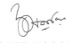
ZOHEB HOSSIAN
ADVOCATE FOR THE APPLICANT FILED ON: 21.02.2022
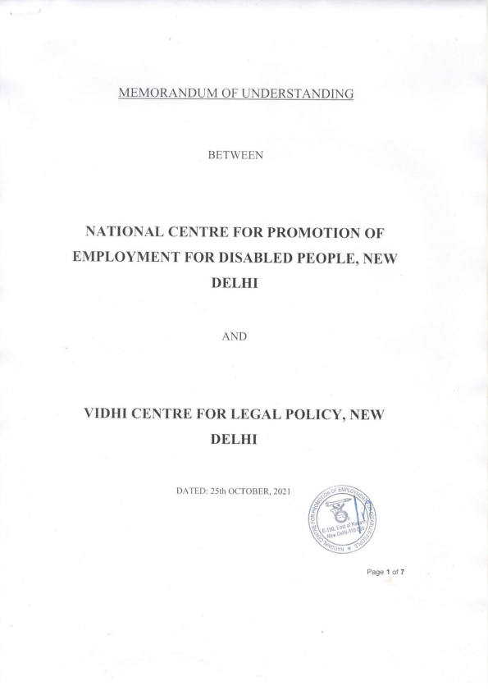19
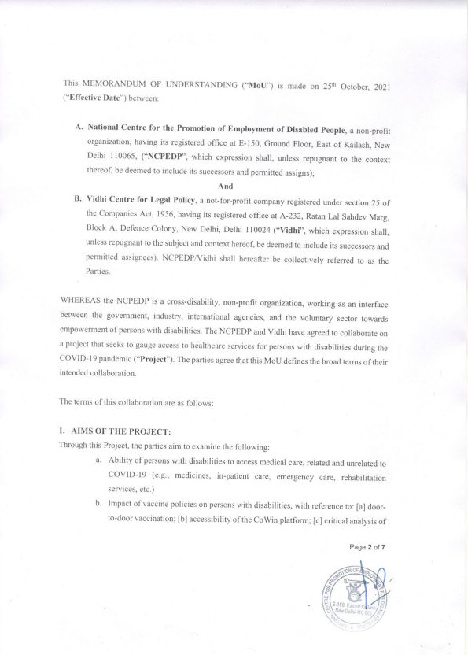20
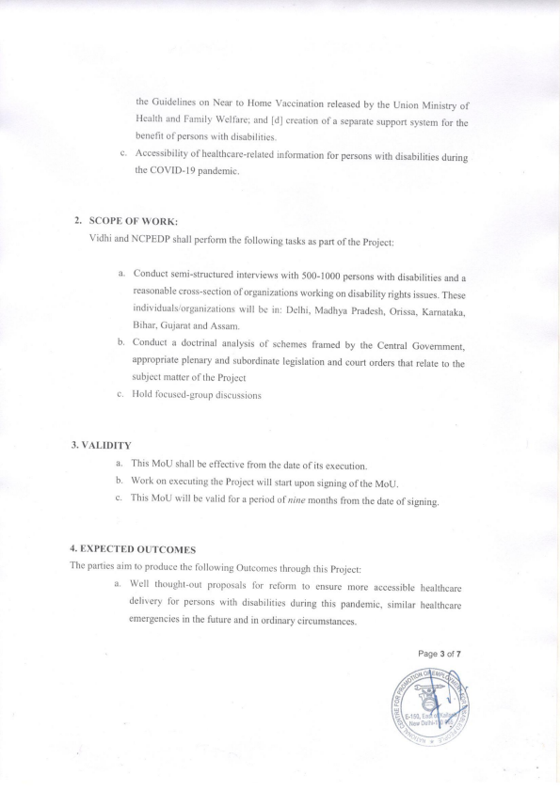21
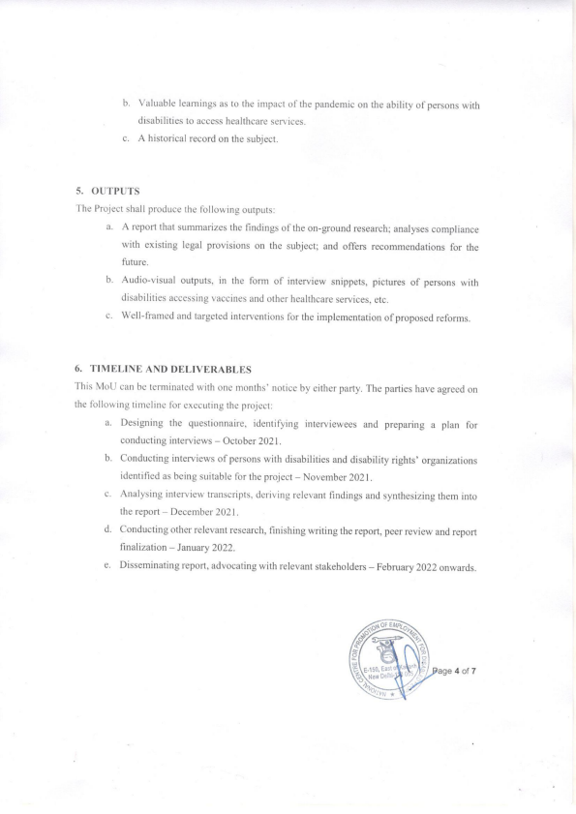22
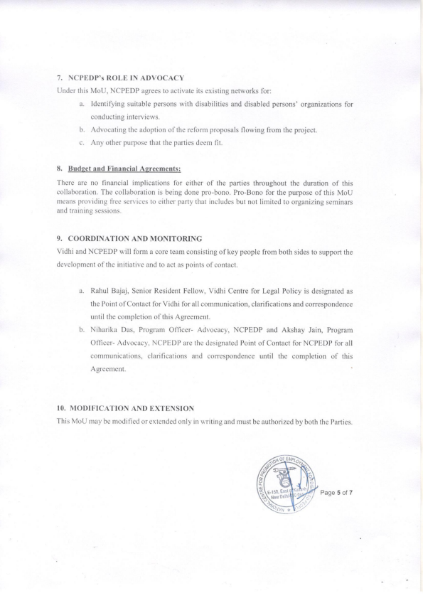23
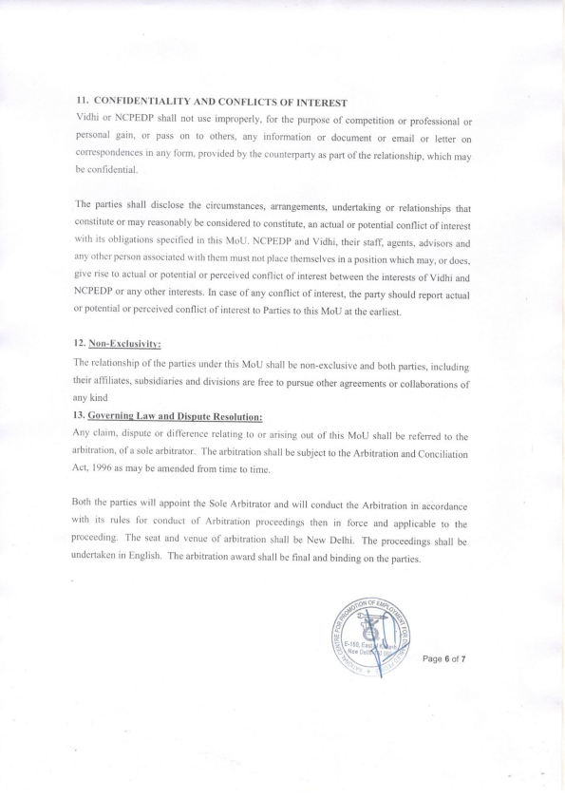24
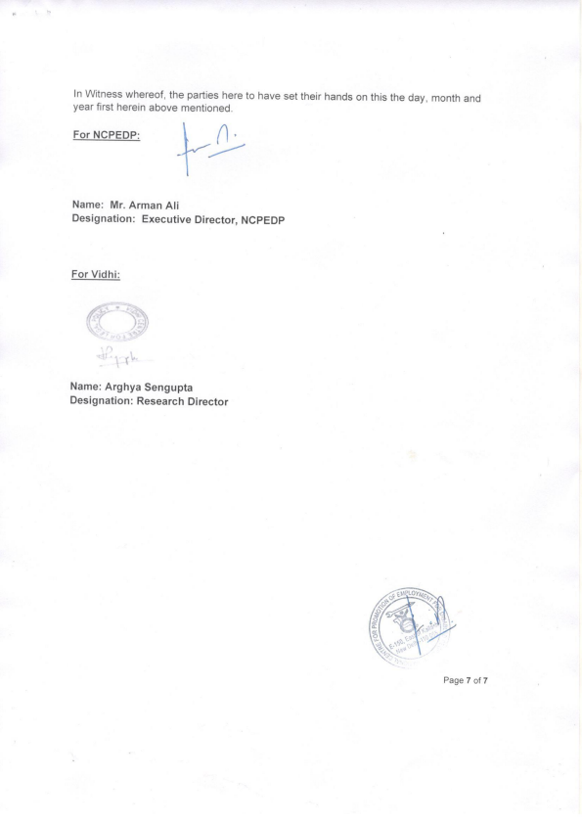25
SCC Online Web Edition, © 2022 EBC Publishing Pvt. Ltd.26Page 1 Monday, February 21, 2022
Printed For: Yeesha Shriyan
SCC Online Web Edition: http://www.scconline.com
TruePrint™ source: Supreme Court Cases, © 2022 Eastern Book Company.
-----------------------------------------------------------------------------------------------------------------------------------------------------------
SCC Online Web Edition, © 2022 EBC Publishing Pvt. Ltd.27Page 2 Monday, February 21, 2022
Printed For: Yeesha Shriyan
SCC Online Web Edition: http://www.scconline.com
TruePrint™ source: Supreme Court Cases, © 2022 Eastern Book Company.
-----------------------------------------------------------------------------------------------------------------------------------------------------------
SCC Online Web Edition, © 2022 EBC Publishing Pvt. Ltd.28Page 3 Monday, February 21, 2022
Printed For: Yeesha Shriyan
SCC Online Web Edition: http://www.scconline.com
TruePrint™ source: Supreme Court Cases, © 2022 Eastern Book Company.
-----------------------------------------------------------------------------------------------------------------------------------------------------------
SCC Online Web Edition, © 2022 EBC Publishing Pvt. Ltd.29Page 4 Monday, February 21, 2022
Printed For: Yeesha Shriyan
SCC Online Web Edition: http://www.scconline.com
TruePrint™ source: Supreme Court Cases, © 2022 Eastern Book Company.
-----------------------------------------------------------------------------------------------------------------------------------------------------------
SCC Online Web Edition, © 2022 EBC Publishing Pvt. Ltd.30Page 5 Monday, February 21, 2022
Printed For: Yeesha Shriyan
SCC Online Web Edition: http://www.scconline.com
TruePrint™ source: Supreme Court Cases, © 2022 Eastern Book Company.
-----------------------------------------------------------------------------------------------------------------------------------------------------------
SCC Online Web Edition, © 2022 EBC Publishing Pvt. Ltd.31Page 6 Monday, February 21, 2022
Printed For: Yeesha Shriyan
SCC Online Web Edition: http://www.scconline.com
TruePrint™ source: Supreme Court Cases, © 2022 Eastern Book Company.
-----------------------------------------------------------------------------------------------------------------------------------------------------------
SCC Online Web Edition, © 2022 EBC Publishing Pvt. Ltd.32Page 7 Monday, February 21, 2022
Printed For: Yeesha Shriyan
SCC Online Web Edition: http://www.scconline.com
TruePrint™ source: Supreme Court Cases, © 2022 Eastern Book Company.
-----------------------------------------------------------------------------------------------------------------------------------------------------------
SCC Online Web Edition, © 2022 EBC Publishing Pvt. Ltd.33Page 8 Monday, February 21, 2022
Printed For: Yeesha Shriyan
SCC Online Web Edition: http://www.scconline.com
TruePrint™ source: Supreme Court Cases, © 2022 Eastern Book Company.
-----------------------------------------------------------------------------------------------------------------------------------------------------------
SCC Online Web Edition, © 2022 EBC Publishing Pvt. Ltd.34Page 9 Monday, February 21, 2022
Printed For: Yeesha Shriyan
SCC Online Web Edition: http://www.scconline.com
TruePrint™ source: Supreme Court Cases, © 2022 Eastern Book Company.
-----------------------------------------------------------------------------------------------------------------------------------------------------------
SCC Online Web Edition, © 2022 EBC Publishing Pvt. Ltd.35Page 10 Monday, February 21, 2022
Printed For: Yeesha Shriyan
SCC Online Web Edition: http://www.scconline.com
TruePrint™ source: Supreme Court Cases, © 2022 Eastern Book Company.
-----------------------------------------------------------------------------------------------------------------------------------------------------------
SCC Online Web Edition, © 2022 EBC Publishing Pvt. Ltd.36Page 11 Monday, February 21, 2022
Printed For: Yeesha Shriyan
SCC Online Web Edition: http://www.scconline.com
TruePrint™ source: Supreme Court Cases, © 2022 Eastern Book Company.
-----------------------------------------------------------------------------------------------------------------------------------------------------------
SCC Online Web Edition, © 2022 EBC Publishing Pvt. Ltd.37Page 12 Monday, February 21, 2022
Printed For: Yeesha Shriyan
SCC Online Web Edition: http://www.scconline.com
TruePrint™ source: Supreme Court Cases, © 2022 Eastern Book Company.
-----------------------------------------------------------------------------------------------------------------------------------------------------------
SCC Online Web Edition, © 2022 EBC Publishing Pvt. Ltd.38Page 13 Monday, February 21, 2022
Printed For: Yeesha Shriyan
SCC Online Web Edition: http://www.scconline.com
TruePrint™ source: Supreme Court Cases, © 2022 Eastern Book Company.
-----------------------------------------------------------------------------------------------------------------------------------------------------------
SCC Online Web Edition, © 2022 EBC Publishing Pvt. Ltd.39Page 14 Monday, February 21, 2022
Printed For: Yeesha Shriyan
SCC Online Web Edition: http://www.scconline.com
TruePrint™ source: Supreme Court Cases, © 2022 Eastern Book Company.
-----------------------------------------------------------------------------------------------------------------------------------------------------------
SCC Online Web Edition, © 2022 EBC Publishing Pvt. Ltd.40Page 15 Monday, February 21, 2022
Printed For: Yeesha Shriyan
SCC Online Web Edition: http://www.scconline.com
TruePrint™ source: Supreme Court Cases, © 2022 Eastern Book Company.
-----------------------------------------------------------------------------------------------------------------------------------------------------------
SCC Online Web Edition, © 2022 EBC Publishing Pvt. Ltd.41Page 16 Monday, February 21, 2022
Printed For: Yeesha Shriyan
SCC Online Web Edition: http://www.scconline.com
TruePrint™ source: Supreme Court Cases, © 2022 Eastern Book Company.
-----------------------------------------------------------------------------------------------------------------------------------------------------------
SCC Online Web Edition, © 2022 EBC Publishing Pvt. Ltd.42Page 17 Monday, February 21, 2022
Printed For: Yeesha Shriyan
SCC Online Web Edition: http://www.scconline.com
TruePrint™ source: Supreme Court Cases, © 2022 Eastern Book Company.
-----------------------------------------------------------------------------------------------------------------------------------------------------------
SCC Online Web Edition, © 2022 EBC Publishing Pvt. Ltd.43Page 18 Monday, February 21, 2022
Printed For: Yeesha Shriyan
SCC Online Web Edition: http://www.scconline.com
TruePrint™ source: Supreme Court Cases, © 2022 Eastern Book Company.
-----------------------------------------------------------------------------------------------------------------------------------------------------------
SCC Online Web Edition, © 2022 EBC Publishing Pvt. Ltd.44Page 19 Monday, February 21, 2022
Printed For: Yeesha Shriyan
SCC Online Web Edition: http://www.scconline.com
TruePrint™ source: Supreme Court Cases, © 2022 Eastern Book Company.
-----------------------------------------------------------------------------------------------------------------------------------------------------------
SCC Online Web Edition, © 2022 EBC Publishing Pvt. Ltd.45Page 20 Monday, February 21, 2022
Printed For: Yeesha Shriyan
SCC Online Web Edition: http://www.scconline.com
TruePrint™ source: Supreme Court Cases, © 2022 Eastern Book Company.
-----------------------------------------------------------------------------------------------------------------------------------------------------------
SCC Online Web Edition, © 2022 EBC Publishing Pvt. Ltd.46Page 21 Monday, February 21, 2022
Printed For: Yeesha Shriyan
SCC Online Web Edition: http://www.scconline.com
TruePrint™ source: Supreme Court Cases, © 2022 Eastern Book Company.
-----------------------------------------------------------------------------------------------------------------------------------------------------------
SCC Online Web Edition, © 2022 EBC Publishing Pvt. Ltd.47Page 22 Monday, February 21, 2022
Printed For: Yeesha Shriyan
SCC Online Web Edition: http://www.scconline.com
TruePrint™ source: Supreme Court Cases, © 2022 Eastern Book Company.
-----------------------------------------------------------------------------------------------------------------------------------------------------------
SCC Online Web Edition, © 2022 EBC Publishing Pvt. Ltd.48Page 23 Monday, February 21, 2022
Printed For: Yeesha Shriyan
SCC Online Web Edition: http://www.scconline.com
TruePrint™ source: Supreme Court Cases, © 2022 Eastern Book Company.
-----------------------------------------------------------------------------------------------------------------------------------------------------------
SCC Online Web Edition, © 2022 EBC Publishing Pvt. Ltd.49Page 24 Monday, February 21, 2022
Printed For: Yeesha Shriyan
SCC Online Web Edition: http://www.scconline.com
TruePrint™ source: Supreme Court Cases, © 2022 Eastern Book Company.
-----------------------------------------------------------------------------------------------------------------------------------------------------------
SCC Online Web Edition, © 2022 EBC Publishing Pvt. Ltd.50Page 25 Monday, February 21, 2022
Printed For: Yeesha Shriyan
SCC Online Web Edition: http://www.scconline.com
TruePrint™ source: Supreme Court Cases, © 2022 Eastern Book Company.
-----------------------------------------------------------------------------------------------------------------------------------------------------------
SCC Online Web Edition, © 2022 EBC Publishing Pvt. Ltd.51Page 26 Monday, February 21, 2022
Printed For: Yeesha Shriyan
SCC Online Web Edition: http://www.scconline.com
TruePrint™ source: Supreme Court Cases, © 2022 Eastern Book Company.
-----------------------------------------------------------------------------------------------------------------------------------------------------------
SCC Online Web Edition, © 2022 EBC Publishing Pvt. Ltd.52Page 27 Monday, February 21, 2022
Printed For: Yeesha Shriyan
SCC Online Web Edition: http://www.scconline.com
TruePrint™ source: Supreme Court Cases, © 2022 Eastern Book Company.
-----------------------------------------------------------------------------------------------------------------------------------------------------------
SCC Online Web Edition, © 2022 EBC Publishing Pvt. Ltd.53Page 28 Monday, February 21, 2022
Printed For: Yeesha Shriyan
SCC Online Web Edition: http://www.scconline.com
TruePrint™ source: Supreme Court Cases, © 2022 Eastern Book Company.
-----------------------------------------------------------------------------------------------------------------------------------------------------------
SCC Online Web Edition, © 2022 EBC Publishing Pvt. Ltd.54Page 29 Monday, February 21, 2022
Printed For: Yeesha Shriyan
SCC Online Web Edition: http://www.scconline.com
TruePrint™ source: Supreme Court Cases, © 2022 Eastern Book Company.
-----------------------------------------------------------------------------------------------------------------------------------------------------------
SCC Online Web Edition, © 2022 EBC Publishing Pvt. Ltd.55Page 30 Monday, February 21, 2022
Printed For: Yeesha Shriyan
SCC Online Web Edition: http://www.scconline.com
TruePrint™ source: Supreme Court Cases, © 2022 Eastern Book Company.
-----------------------------------------------------------------------------------------------------------------------------------------------------------
56
IN THE HIGH COURT OF JUDICATURE AT MADRAS DATED: 19.04.2021
CORAM :
The Hon'ble Mr.SANJIB BANERJEE, THE CHIEF JUSTICE AND
The Hon'ble Mr.JUSTICE SENTHILKUMAR RAMAMOORTHY W.P.No.2951 of 2021
Meenakshi Balasubramanian .. Petitioner -vs
1.The Union of India,
Rep. by its Secretary,
Ministry of Health and Family Welfare
Room No.348; 'A' Wing, Nirman Bhavan,
New Delhi 110 011.
2.The State of Tamilnadu,
Rep. by its Secretary,
Health and Family Welfare Department,
Fort St. George, Chennai 600 009. .. Respondents
Petition filed under Article 226 of the Constitution of India praying for issue of Writ of Mandaus to direct the 1st respondent to include Persons with Disability and their caregivers as a priory group for administering COVID-19 vaccine.
For Petitioner : Mr.A.Yogeshwaran
For Respondents : Mr.D.Simon
Central Govt. Stdg. Counsel
for R-1
: Mr.V.Jayaprakash Narayanan
State Government Pleader
for R -2
ORDER
(Made by The Hon'ble Chief Justice)
The matter pertains to disabled persons being given priority in the process of vaccination. Unfortunately, the complete lack of action on the part of the Union has delayed the matter and only today certain documents have been filed on behalf of the Union.
2. Pursuant to an observation made by this Court when the matter was last taken up and the Union was not represented, the State is agreeable to provide a separate counter at all vaccination centres run by the Government all over the State to
https://hcservices.ecourts.gov.in/hcservices/
57
vaccinate only persons with disabilities.
3. The petitioner seeks to make out that persons with disabilities are more vulnerable and claims that they are at least six times more at risk than others. The petitioner suggests that the age restriction that is otherwise in vogue, should not be applied to persons with disabilities.
4. As of now, the guidelines issued by the Union provide for vaccination to all persons who have crossed the age of 45, irrespective of whether they suffer from any co-morbidity. In addition, frontline workers even below the age of 45 and those who are at risk have been or are being administered the vaccine. However, as far as this Court is informed, vaccination is available only to adults.
-5. The Court must be careful in issuing an order so that the good that is sought to be achieved thereby is not undone by an uninformed decision which may have an adverse effect. Accordingly, the statement of the State is recorded that all Government vaccination centres will have a separate counter throughout the day when vaccination is undertaken at such centres exclusively for persons with disabilities. At any rate, persons with disabilities should be given priority in being vaccinated even if the numbers do not warrant an exclusive counter being set up at every Government vaccination centre. The Union has relied on a document appended at page 21 of the typed set filed on behalf of the Union on March 19, 2021. The last entry is in the form of a certificate to identify individuals with co-morbidities that enhance the risk of mortality. Item 20 in the list of criteria deals with persons with disabilities due to intellectual disabilities/muscular dystrophy/acid attack with involvement of respiratory system/person with disabilities having high support needs/ multiple disabilities including deaf-blindness.
6. Though the document apparently otherwise restricts the eligibility age of vaccination to 45 years and above, in the current context of all persons 45 years and above being eligible for vaccination, there would be no meaning to provide for an additional certificate if the form is also interpreted to apply only to those who have attained the age of 45. Accordingly, the State is directed to give priority to such persons suffering from disability as indicated in the relevant Annexure, irrespective of whether such person has attained the age of 45 but subject to a previous reasoned basis being arrived at as to what would be the minimum appropriate age for a person to be vaccinated. Such decision should be taken by the State within the next three days and in consultation with the Union, if necessary. The primary consideration in determining the minimum
https://hcservices.ecourts.gov.in/hcservices/
58
age would be whether the various vaccines have an adverse impact on infants, children or persons who have not attained adulthood. The manufacturers may also be consulted in such regard as to the adverse effect of the relevant vaccination on persons upto or below a particular age.
7. It needs to be emphasized that every care should be taken to obtain information and arrive at a reasoned decision as to the appropriate age before the vaccination is opened up to persons suffering with disabilities or the kind of disabilities indicated in the relevant document relied upon by the Union. The State may also consider administering vaccine to persons above the age of 18 but suffering from any form of disability as indicated in the Schedule to the Rights of Persons with Disabilities Act, 2016 instead of confining it to the disabilities indicated in the Union's annexure. Every endeavour should be made by the State to enable vaccination as expeditiously as possible to protect the lives of persons with disabilities. Immediate steps should be taken by the State to ensure that vaccination centres are accessible to persons with disabilities by constructing ramps or other measures in accordance with the said Act of 2016.
8. W.P.No.2951 of 2021 is disposed of. There will be no order as to costs.
Sd/-
Assistant Registrar
//True Copy//
Sub Assistant Registrar
sra
To
1.The Secretary to Govt. of India,
Ministry of Health and Family Welfare
Room No.348; 'A' Wing, Nirman Bhavan,
New Delhi 110 011.
2.The Secretary to State of Tamilnadu,
Health and Family Welfare Department,
Fort St. George, Chennai 600 009.
+1 cc to Government Pleader, SR.NO.24035
+1 cc to Mr.Dr.D.Simon, Central Government Standing Counsel, SR.NO.23551
W.P.No.2951 of 2021
RLD(CO)
NS(11/05/2021)
https://hcservices.ecourts.gov.in/hcservices/
59
22
22
60
61
62

