How Accessible is Education for Students with Visual Disabilities|An Analysis of Digital Resources

March 2021

This report is an independent, non-commissioned piece of work by the Vidhi Centre for Legal Policy, an independent think-tank doing legal research to help make better laws and improve governance for the public good.

About the Authors

Nisha Vernekar, Team Lead, Education
Tapas Bhardwaj, Project Expert
Pooja Pandey, Project Fellow
Naina Seth, Project Fellow
Acknowledgements

This Report has been produced as part of the Kotak-Vidhi Inclusive Education Programme. Kotak Mahindra Bank Limited supports this programme in furtherance of its CSR programme.

The authors would like to thank Dhvani Mehta for her guidance, Advaita Rajendra for peer reviewing the report, and Masooma Rizvi for excellent research assistance.

Finally, the authors would like to extend their heartfelt gratitude to Sanya Gandhi, Mayank Bhardwaj, Tejaswi Raj and Mrs. Manorama Raj, Mr. Anirban Mukherjee and Mrs. Arunima Dasgupta, who spared their valuable time to share their experiences as students, teachers and parents.

Contents
1. Background 5
2. Methodology 5
Sample Selection 5
Assessment of (In)accessibility 6
3. Key Findings 7
Inaccessibility of the web and mobile phone DIKSHA platform 7
Inaccessibility of TLM resources hosted on DIKSHA platform 8
Inaccessibility of Learning Activities 9
4. Recommendations 12

Background
In June 2020, the Vidhi Centre for Legal Policy published a Briefing Book titled, ‘Towards a Post-COVID India: 25 Governance Challenges and Legal Reforms’ of which one entry, ‘Making Digital Education Inclusive’ highlighted the legal and policy gaps in making digital education modes and platforms accessible and inclusive for students with disabilities. The current report is an extension of this Briefing Book entry that aims to re-emphasise India’s legal obligation to make all educational content available in audio, print and electronic media accessible to persons with disabilities.
Students with disabilities struggle to access schooling, including access to digital modes of education, with those from rural and socio-economically disadvantaged backgrounds being the worst affected according to a UNESCO study published in 2019. The question of accessibility of digital education resources is especially urgent in light of the COVID-19 pandemic where reliance on digital education has substantially increased for students and teachers. For students with visual disabilities, accessibility also includes the use of digital tools that can improve their ability to easily navigate materials and access content without relying on Braille textbooks.
The Right for Persons with Disabilities Act (RPWD) 2016, under the mandate for all public schools to provide inclusive education, directs government authorities to make “reasonable accommodation” according to the needs of students and ensure that education to students with visual disabilities is imparted in appropriate language and modes of communication, under sections 16(iii) and 16(v) of the Act, respectively. Section 17(i) further directs government authorities to “make suitable modifications in the curriculum and examination system to meet the needs of students with disabilities…”. Despite this, this study finds that educational resources hosted on the Centre’s much touted Digital Infrastructure for Knowledge Sharing (DIKSHA) platform fail to be accessible to students with visual disabilities.
A recent petition filed by the National Association for the Blind (NAB) in the Bombay High Court regarding inaccessibility of digital education also raised the issue of inaccessibility of the DIKSHA platform for students with visual disabilities. Keeping abreast with the recent developments in the PIL, this study aims to provide empirical evidence of the ‘extent of inaccessibility’ of learning materials hosted on the DIKSHA platform and suggestions on how it can be improved.
This report conducts a systematic review of the accessibility of the (DIKSHA) portal and a sample of learning resources hosted on it. The DIKSHA portal is ‘a national platform for school education’, initiated by the National Council for Education Research and Training (NCERT), Ministry of Education, India. Owing to its popularity and wide coverage across India, DIKSHA provides a unique opportunity to empirically assess the extent of inaccessibility of the Teaching and Learning Materials (TLM) used across the country. Beyond accessibility of e-learning resources, this study also uncovers the urgent need for updating the curriculum and content of textbooks to ensure inclusion of students with visual disabilities.

Methodology

2.1 Sample Selection
The DIKSHA platform compiles learning and teaching resources across curriculum boards and media of instruction. These resources include e-textbooks; video/audio content (including videos of television classes hosted by various state governments); documents of practice questions; supplementary reading materials (such as annotated notes, Power Point presentations, activity sheets); and resources for teachers.

The compilation of learning resources on the platform happens through a crowdsourcing system wherein teachers and other members/employees of recognized educational institutions and non-governmental organisations can enrol and register themselves on the platform, and upload learning resources. All resources uploaded are ‘sent for review’, and post approval are hosted on the platform. These materials represent learning resources available and used by students in schools across the country. This also means that what learning resources can be found on the platform under each state, curriculum board, subject or medium of instruction, largely depend on whether registered members upload content and what content they upload.

A preliminary review conducted between January and February 2021 on materials hosted across states showed that e-textbooks were available for majority states, and that 20 states listed NCERT textbooks, either solely or along with SCERT materials. NCERT e-textbooks are thus the primary learning materials assessed in this study. Some states such as Gujarat, West Bengal, Tamil Nadu, and Telangana, listed only SCERT textbooks. Thus, SCERT e-textbooks listed under two additional states (that did not host NCERT e-textbooks) were also sampled. The sample thus covers materials hosted on the DIKSHA platform under 22 states at the time of data collection.

A sample of 65 chapters from NCERT and SCERT (State Council of Educational Research and Training) textbooks were selected for analysis, making up approximately 10% of the total number of chapters in textbooks for the respective curriculum boards. These were 22 chapters from NCERT e-textbooks and 22 and 21 from SCERT e-textbooks for Telangana and Tamil Nadu, respectively. This data was collected between December 2020 and January 2021.
Sampled chapters from NCERT e-textbooks were selected for English, Mathematics, Science, Geography, History, and Economics, for grades 1, 5, 8 and 10. Sampled chapters from SCERT e-textbooks for the state of Tamil Nadu were sampled for grades 1, 5, 8 and 10, for Mathematics, English, Environmental Studies (EVS), Science, and Social Sciences. Sampled chapters from Telangana SCERT e-textbooks were sampled for grades 1, 5, 8 and 10 across English, Mathematics, EVS, Social Science and Sciences.
A limitation in testing chapters was that the screen reader software used by the research team could only read materials in English medium. As a result, states such as Gujarat or West Bengal that had (at the time of data collection) only uploaded materials in regional languages were not considered for the sample.

2.2 Assessment of (In)accessibility

2.2.1 Types of Inaccessibility
The assessment of accessibility aimed to capture three aspects of accessibility for a student with visual disabilities:
- DIKSHA website and mobile application: The possibility for a student to independently navigate the DIKSHA web portal and mobile app such that they can find the TLM they are seeking (by state, language of instruction, grade, subject, and chapter), and download or open the material.
- Resources hosted on the DIKSHA platform: The possibility of being able to navigate through the TLM using a screen-reading software. This primarily requires that the TLM (NCERT and SCERT e-textbooks sampled) be uploaded in an appropriate e-text format. Even when uploaded in an appropriate format, TLM may include various elements such as images, tables or watermarks that are inaccessible to a screen reader and make it difficult for a student with visual disabilities to follow the content. This is explained in greater detail in Appendix A.
- Accessibility of ‘learning activities’: Additionally, an assessment of the accessibility of ‘learning activities’ was undertaken for the sample of NCERT textbooks alone. Learning activities are defined as activities students are instructed to do while reading a chapter. Chapters often have activities, questions or problems that students must solve to ensure their understanding of new concepts. When these are heavily reliant on images or other inaccessible elements of a chapter, they are inaccessible for students with visual disabilities. For instance, in a mathematics textbook for grade 1, children are asked to look at images of two lines of different widths and choose the image that is thicker. This reaffirms pre-numeracy concepts of relative comparisons between objects. However, for a student with visual disabilities, a learning activity that is reliant on being able to see images is inaccessible. While all elements of textbooks should be accessible, the true harm to students with visual disabilities comes from learning activities that are not accessible to them.

2.2.2 Method of testing
Accessibility of the interface of the portal’s website and phone application were tested using two screen reading software- JAWS and NVDA.

Accessibility checks on the platform were conducted in three ways. First a member of the research team with a visual disability documented his experience of navigating the website and mobile application. Secondly, the researcher was provided the sampled NCERT and SCERT e-textbook chapters. A similar documentation of his experience was collected in identifying inaccessibility of the TLM. In both cases, the researcher used both, the JAWS and NVDA software.

Finally, sighted members of the research team used the NVDA’s “screen viewer” tool to conduct an independent accessibility check. This tool created a document of what the screen-reader is able to read, allowing a sighted user to accurately assess the accessibility of the materials for a person with visual disabilities.

Key Findings

3.1 Inaccessibility of the web and mobile phone DIKSHA platform

3.1.1 Web platform
The DIKSHA platform is designed such that a student or teacher can search for learning materials by their state, medium of instruction and curriculum boards, within which they can look for materials for their grade, subjects and chapters within subjects. However, for a student with visual disability using a screen reader, the web platform has a variety of accessibility issues that make it difficult for them to independently navigate it to search and access the content they are looking for.

Take for example, the drop down menu for language selection. Rather than clearly stating different language options available, the screen reader announces “clickable, clickable, clickable”. This is due to different scripts used for the different languages, which are not readable by a screen reading software. Similarly, the filter for selecting grades is not accessible with a screen reader. Finally, even if a student is able to find the relevant page with the textbooks and other learning materials to select from, the links for opening or downloading materials are not properly labelled so students with visual disabilities cannot tell what materials they are downloading.

Links for TLM (apart from the primary resource of e-textbooks) were also tested to assess whether a student with visual disabilities could locate links to TLM and access/ download the materials with the use of a screen reader alone. This included 22 links to i) supplementary learning resources, ii) chapter explanation videos, and iii) documents with practice questions. We found that a student with visual disabilities could independently navigate only 31.8% of the links.

Figure 1: Navigating links of learning resources
68.2%

Links to learning resources cannot be accessed independently using screen reader

3.1.2 Mobile platform
The mobile application of the DISKHA platform had only a few elements, such as QR codes, that could not be used independently by a student with visual disability. However, the mobile application is only available for android devices, despite IOS being more accessible for persons with visual disability. Additionally, it is key to note that while the DIKSHA mobile application designed, is far more accessible than the DIKSHA web platform, students with visual disabilities in general find it easier to navigate reading materials on laptops as screen reading software provide various shortcuts and other capabilities when using a keyboard. This necessitates that the DIKSHA website be made accessible regardless of the mobile app. A more detailed description of the issues of navigability are provided in Appendix B.

3.2 Inaccessibility of TLM resources hosted on DIKSHA platform

3.2.1 Inaccessibility of learning materials reported have been clubbed into two categories
- Complete inaccessibility: Documents/ e-textbooks are not uploaded in appropriate e-text formats, meaning that a screen reader is unable to navigate any part of the material. Even when materials are uploaded in the appropriate e-text format, in some cases multiple pages within a chapter are uploaded in inappropriate formats, such that a screen reader skips on to the next accessible page. This makes it impossible for a student with visual disabilities to follow the content. To provide an example, in a mathematics chapter consisting of 48 pages, 34 pages or 70.1% of the pages were not accessible to a screen-reader. As a result, such chapters are also categorized as being “completely inaccessible”.
- Partial inaccessibility: Where uploaded in an appropriate e-text format such that the screen reader can navigate the document broadly, it, nevertheless, contains elements, such as images, tables, graphs, watermarks, etc., that make it difficult for a student with visual disabilities to fully comprehend the content of the material.

3.2.2 Accessibility of sample chapters:

Figure 2: Accessibility of NCERT chapters (uploaded for 20 states)
36%
55%
9%
Partially Inaccessible

Completely Accessible
Completely Inaccessible

All 22 chapters sampled from NCERT e-textbooks were uploaded in an appropriate e-text format of which 36.4% were completely accessible. However, 54.5% were partially inaccessible, and 9.1% were completely inaccessible.
Figure 3: Accessibility of SCERT chapters (uploaded for Tamil Nadu)
91%
4.5%
4.5%

Completely Accessible
Partially Inaccessible

Completely Inaccessible

Of the 21 SCERT chapters sampled for Tamil Nadu, 90.5% were completely inaccessible. Of the remaining chapters, 1 was partially inaccessible (included inaccessible elements such as tables and images without descriptions). Only one of the sampled chapters was completely accessible using a screen reader.

Figure 4: Accessibility of SCERT chapters (uploaded for Telangana)
0%
96%
4%
Partially Inaccessible

Completely Accessible
Completely Inaccessible

Of the 22 SCERT chapters sampled for Telengana, none were completely inaccessible, however 95.5% were partially inaccessible, and only one chapter was completely accessible.
Table 1: Accessibility of sampled chapters
Assessment | Tamil Nadu SCERT | Telangana  SCERT | NCERT
Completely Accessible (%) | 4.50% | 4.50% | 36.40%
Completely Inaccessible (%) | 90.50% | 0 | 9.10%
Partially Accessible (%) | 4.50% | 95.50% | 54.50%
Total no. Chapters | 21 | 22 | 22

3.3 Inaccessibility of Learning Activities
Across the 22 sampled chapters from the NCERT, a total of 907 learning activities were identified, of which 52.6% were inaccessible to a student using a screen reader. More crucially, no alternative activities were provided for students with visual disabilities, implying they are potentially forced to skip these activities altogether. This further varied by subject and grade, where it was expected that Science, Technology, Engineering and Mathematics (STEM) subjects and chapters for higher grades would be more inaccessible.

Figure 5: Accessibility of Learning Activities in Curriculum
NCERT learning activities were inaccessible
Grade 1 learning activities were inaccessible
94.2%
80%
52.6%
Mathematics learning activities were inaccessible

Mathematics chapters had the highest number of inaccessible learning activities at 80%. English Science and Geography chapters had 49.1%, 33.9% and 32.8% inaccessible learning activities, respectively. Economics chapters had 23.1% inaccessible learning activities.
Table 2: Inaccessibility of learning activities by subject
Subjects | Inaccessible learning activities | No. of Learning Activities
Mathematics | 80.00% | 360
English | 49.10% | 110
Science | 33.90% | 304
Geography | 32.80% | 61
Economics | 23.10% | 52
History | 0.00% | 20
Total | 52.6 | 907

Chapters sampled from grade 1 had the highest extent of inaccessible learning activities at 94.2%. This was followed by grade 8 chapters at 54.6% and grade 10 chapters at 48%.
Table 3: Inaccessibility of learning activities by grade
Grade | Inaccessible learning activities | No. of learning activities | Subjects
Grade 1 | 94.20% | 138 | Eng, Math
Grade 5 | 22.60% | 155 | Eng, Math, Science
Grade 8 | 54.60% | 262 | Eng, Math, Science, Geography
Grade 10 | 48.00% | 352 | Math, Science, Geography, History, Economics
Total | 52.6 | 907

However, this is likely partially led by the selection of subjects within grades. Grade 1 for example had sampled chapters only from Mathematics and English textbooks. The next set of tables compares inaccessibility of the same subject across grades.
Mathematics chapters were selected from all four grades. In the table below grades 1 and 5 are clubbed under primary and grades 8 and 10 are clubbed under secondary. We find mathematics chapters from primary grades have only a marginal 2% higher number of inaccessible learning activities than mathematics chapters from secondary grades.
Table 4: Inaccessibility of learning activities in mathematics by level of schooling
Grade- subject | Inaccessible learning activities | No. of learning activities
Math (primary) | 81.3% | 123
Math (secondary) | 79.3% | 237
Total in Math | 80 | 360

English chapters were sampled only for grades 1, 5, and 8. Grade 1 chapters had considerably more inaccessible learning activities at 58.2%, compared to 21.2% and 0% inaccessible learning activities in Grade 5 and Grade 8 chapters, respectively. This suggests that the high inaccessibility of Grade 1 chapters might be regardless of the subjects sampled.

Table 5: Inaccessibility of learning activities in English by level of schooling
Subject (Grade) | Inaccessible learning activities | No. of learning activities
English (1) | 58.2% | 55
English (5) | 21.2% | 33
English (8) | 0 | 22
Total in English | 35.5 | 110

Science chapters were sampled only for grades 5, 8 and 10. Chapters from grades 8 and 10 had a higher extent of inaccessible learning activities with about 41% and 42% respectively, compared to only 13.4% inaccessible learning activities in grade 5 science chapters sampled.
Table 6: Inaccessibility of learning activities in Science by level of schooling
Subject (Grade) | Inaccessible learning activities | No. of learning activities
Science (5) | 13.4% | 82
Science (8) | 41.0% | 78
Science (10) | 41.7% | 144
Total in Science | 33.9 | 304

Recommendations
The Rights of Persons with Disabilities Act 2016, enacted to implement the UN Convention on the Rights of Persons with Disabilities (ratified by India in 2006) directs all the appropriate government authorities to provide ‘inclusive education’ to children with disabilities. Inclusive education under the Act is defined as a, “… system of teaching and learning [that] is suitably adapted to meet the learning needs of different types of students with disabilities”. As such, the Act directs government authorities to provide “reasonable accommodation” to meet individual requirements of students under Section 16(iii), and in doing so “to make suitable modifications in the curriculum and examination system to meet the needs of students with disabilities… ”, under Section 17(i).

The RPWD Act 2016 puts the onus of accessibility of educational resources for students with disabilities, including students with visual disabilities, solely on the state as providers of education. Yet this study finds that much of the learning materials hosted on the Centre’s DIKSHA platform are not accessible to students with visual disabilities and the platform itself is not navigable with the use of a screen reader.

4.1 Making digital education accessible for all

Mandates under law and recommendations under policy | Suggestions
- Rule 15(1)(c)(i) of the Rights of Persons with Disability Rules, 2017 mandates adoption of guidelines developed by the Indian Government for government-run websites (GIGW guidelines)  - Telecom Regulatory Authority of India (TRAI)’s Recommendations on Making ICT Accessible for Persons with Disabilities, 2018  - Web Content Accessibility Guidelines (WCAG 2.1) laid down by the World Wide Web Consortium (W3C) | Make the DIKSHA website and mobile application universally accessible by adopting GIGW guidelines, and in accordance with guidelines of TRAI recommendations and WCAG 2.1 guidelines.
- Section 17(a) of the RPWD Act 2016 directs government authorities “to conduct survey of school going children in every five years for identifying children with disabilities, ascertaining their special needs and the extent to which these are being met”. | Conduct systematic accessibility audits of the DIKSHA web platform to ensure that it meets universal standards of accessibility. Given the dynamic nature of the platform and resources hosted on it, such a check should necessarily be done routinely.
- Rule 15(1)(c)(ii) of the Rights of Persons with Disability Rules 2017, mandates that documents that are placed on websites shall be in electronic Publication (EPUB) or Optical Character Reader (OCR) based PDF formats. | The process of approval of TLM on the DIKSHA platform should include an accessibility check of materials and the formats in which they have been uploaded to minimize uploading content in violation of these rules.
- Schedule to the RTE Act, 2009 | Given the increased focus on digital education in the National Education Policy 2020 and necessitated by the COVID-19 pandemic, the Schedule to the RTE Act should be amended to include norms and standards on inclusive digital education that are applicable to schools

4.2 Making Teaching and Learning Materials accessible for all
Beyond web accessibility however, this study finds that more than half of ‘learning activities’ in textbooks across subjects and grades are inaccessible for students with VI. This suggests that even if the guidelines for web accessibility are met, the true impediment to inclusion in the classroom is built into the curriculum.

Mandate of RPWD Act 2016 | Suggestions
- Section 17(a) directs government authorities “to conduct survey of school going children in every five years for identifying children with disabilities, ascertaining their special needs and the extent to which these are being met” | The process of ascertaining whether the needs of students are being met should necessarily include accessibility checks on the TLM provided to, and used by students across disability types
- Section 17(a)  - Section 17(i) directs government authorities to “make suitable modifications in the curriculum and examination system to meet the needs of students with disabilities…” | Sub-sections 17(a) and 17(i) of the RPWD Act when read together require that all TLM be reviewed systematically and regularly, to ensure curriculum does not exclude students with varying disabilities by design. Where inaccessible, learning activities should be altered for greater inclusion, and alternatives must be provided for students and teachers where they cannot be altered.
- Section 17(i) | Going forward, universal accessibility norms should be made an integral part of the content creation process rather than a supplementary exercise.
- Section 17(d) mandates that the State must “train professionals and staff to support inclusive education at all levels of school education” | As such, the DIKSHA platform should encourage and host resources created by special educators for mainstream teachers that provide pedagogical direction and ideas for greater inclusion of students with visual disabilities and other disabilities in their classrooms.

Appendices

Appendix A: Inaccessible Elements of TLM
In navigating e-textbooks of the DIKSHA platform with a screen reader, we found elements of the materials that were not accessible. It is key to note here that many of these issues of inaccessibility would persist even if the textbook was in its physical form. In that, it is not a reflection of digital inaccessibility, but rather inaccessibility of the learning materials created by the State.

- Images, Charts and Graphs: Images in the text that do not have captions describing the image mean that the image is inaccessible. When images are referred to in the text and used to describe concepts, inaccessibility is a bigger issue. Charts and graphs are similarly inaccessible and usually used to express some meaning.
- Text-boxes or floating text: Create issues with navigation. In some cases the screen reader skips all text boxes when initially navigating the chapter and then returns to them at the end. In other cases these boxes are skipped altogether. Either way, this makes it difficult for a student with visual disabilities to follow content, especially since such elements are usually used to highlight key points in a chapter.
- Tables: Tables need to be created in a way that ensure they can be easily and correctly navigated with a screen reader. Usually, a screen reader would be able to move from left to right covering each column in a row, before moving on to the next row. However, when a table is inserted as an image, or if the design changes the order in which a screen reader reads the table, the screen reader is unable to move in the above fashion, making it difficult for the student to follow the content. For example in an NCERT textbook a table was being read top to bottom such that it read the Sr. no. in column 1 first and then moved on to the next column. This makes it difficult for a student to follow.
- Mathematical formulae: Cannot always be read by a screen reader. This requires expert advice on how to ensure accessibility of symbols used in equations.
- Watermarks: The presence of watermarks in textbooks created a hurdle for students with visual disabilities as a screen reader would repeat the label of the watermark before the start of every sentence.
- Typographical errors in text should be rectified to ensure a student with visual disabilities can easily understand what is being read out to them. This is a minor issue that needs to be addressed for all students, especially when they are expected to use TLM independently.
- Navigation guides for screen-readers and their users:
  - Table of contents: Can act as an important guide for a student with visual disabilities to navigate a textbook. However, this is often not accessible, in the same way tables in a document are inaccessible (explained above). Additionally, page numbers provided in a Table of Contents are crucial in helping a student with visual disabilities easily navigate through chapters. Thus, if the page numbers in the table are inaccessible or incorrect (do not match pages in the documents), a student with visual disabilities will struggle to use this feature.
  - Use of headings: An e-text format document made accessible for screen reading software usually formats headings in the document in a way that they can be navigated to without requiring to read through the entire text. The software is able to create a ‘list of headings’ when it opens the document, such that a student can navigate easily through headings in the chapter. In the absence of such formatting the screen reader is unable to create such a list, and instead a student would need to listen to the screen reader run through the entire document to find the relevant heading.
  - Link lists: Similar to a list of headings, a screen reading software when a new document or website page is opened. creates “link lists”. This is a list of all links available in the material and can be easily navigated by a student with visual disabilities. However, when links are inappropriately labelled this feature becomes redundant.

Appendix B: Inaccessibility of the DIKSHA web portal and mobile application
- Inaccessibility of the home page
The map giving the details of the usage metrics is inaccessible. The screen reading software doesn’t give a clear description of the map and it makes it difficult to perceive the logic of the map on the home page.

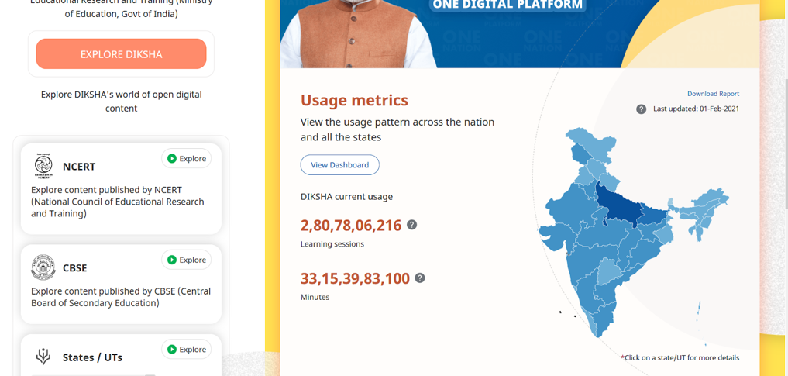

- Inaccessibility of the ‘Explore’ page
  - The drop down menu of different language options on the explore page is inaccessible. Rather than clearly stating different language options available, the screen reader announces “clickable, clickable, clickable”. This is due to different scripts being used for different languages that are not readable by a screen reading software.

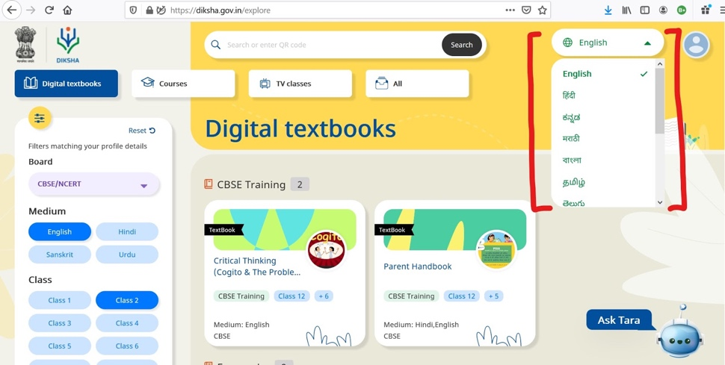

  - Use of link lists: While using a screen reader, a ‘link list’ is created to navigate the website easily. For this platform however, the software was unable to adequately create a link list for the list of books under the ‘explore button’. It was also difficult and confusing to distinguish between the link to open the book and the link to download the books. As a result, it is not possible for students to download books independently (with use of the screen-reader alone), and they would require external assistance.
  - The ‘filter’ option on the left side of the page, selecting different classes, one after the other, results in multiple selection and displays all the course content of the selected classes. There is also an option to un-select classes by clicking on the class tab once again. While this is easy to navigate without the screen-reader, the screen-reader is not able to re-confirm what has been selected, leading to confusion in what content is available.
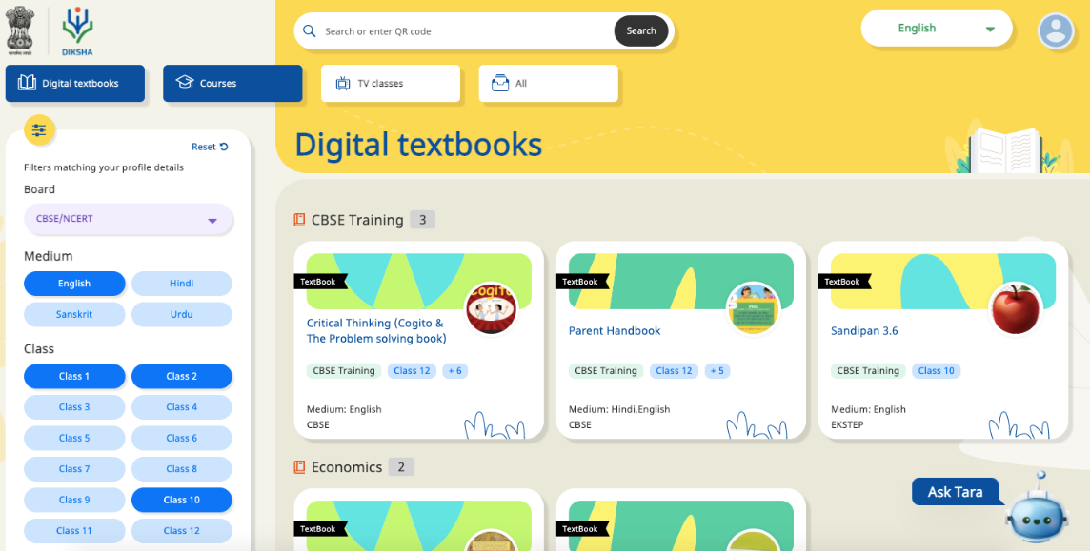

  - Issues of downloading: When downloading a PDF from a website, the download option usually appears on the right side of the PDF after clicking the drop-down option (where two options of ‘share’ and ‘download’ appear). This download option is not accessible through the screen reader and is not appearing while accessing the content of the page.

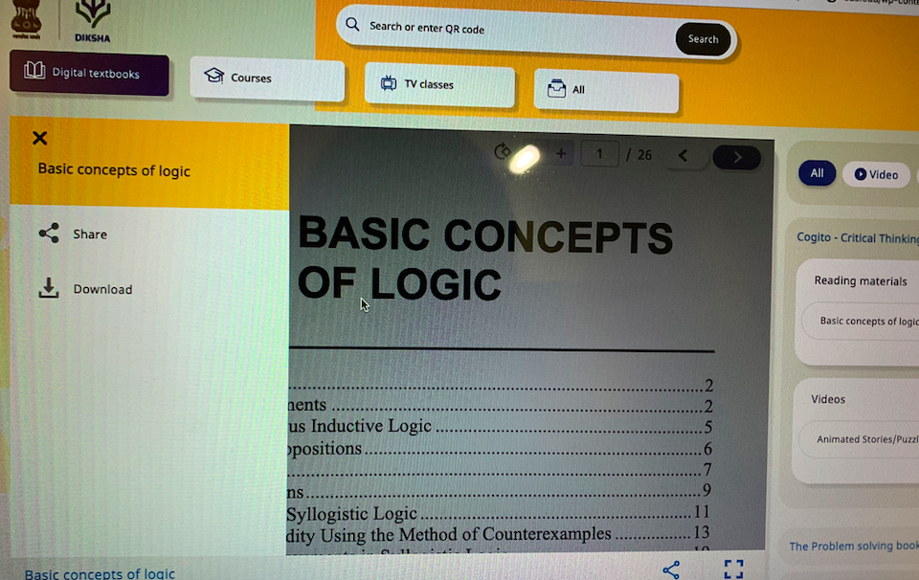

- Technical errors observed when opening videos: In some cases, video content was not accessible, with or without the screen reading software. When videos were opened by a person with visual disability using the screen reading software, it announced ‘fetching content’, and no video played thereafter.

- Improper Labelling: It was also observed that some of the folders had no content, or content different to the name provided to that folder.

Kotak Mahindra Bank Limited supports
the Kotak-Vidhi Inclusive Education Programme
in furtherance of its CSR programme.
This report is authored by
Vidhi Centre for Legal Policy,
under this programme.

www.vidhilegalpolicy.in

Vidhi Centre for Legal Policy
A-232, Defence Colony
New Delhi – 110024
011-43102767/43831699
vclp@vidhilegalpolicy.in

As per the India Digital Report on Remote Learning Initiatives across India 2020, “As of July 2020, it is estimated that… [the site received] more than 30 crore content plays and 200 crore page hits already on DIKSHA.”
A screen reader is an assistive technology, primarily used by people with vision impairments. NVDA and JAWS were selected as they are both open access and commonly used, and are thus easily available to a wider group of students.
Sighted people, when conducting accessibility checks of website and other online materials commonly use the ‘Screen Viewer’ tool of the NVDA software.

